DRS MUN 2026

Background Guide

Freeze Date: 26th June 1948

Letter from the Executive Board

Dear Delegates,
We are very pleased to welcome you to the simulation of the CCC at DRS MUN 2026. It is an honour to serve as your Executive Board for the duration of the conference. This Background Guide is designed to give you an insight into the case at hand, so we hope this acts as only a catalyst for furthering your research and not limited to just this guide. Please refer to it carefully. Remember, a thorough understanding of the problem is the first step to solving it.

Do understand that this Background Guide is in no way exhaustive and is only meant to provide you with enough background information to establish a platform for beginning the research. Delegates are highly recommended to do a good amount of research beyond what is covered in the Guide. The guide cannot be used as proof during the committee proceedings under any circumstances.

We understand that MUN conferences can be an overwhelming experience for first-timers but it must be noted that our aspirations from the delegates are not how experienced or articulate they are. Rather, we want to see how one manages the balance to respect disparities and differences of opinion and work around this while extending their foreign policy to present comprehensive solutions without compromising on their self-interests and initiate consensus building.

New ideas are by their very nature disruptive, but far less disruptive than a world set against the backdrop of stereotypes and regional instability due to which reform is essential in policy making and conflict resolution. At any point during your research, do not hesitate to contact the Executive Board Members for clarifications or in case you need help in any other aspect. We look forward to a fruitful discussion and an enriching experience with all of you.

Best regards,

Eswar Chava Avani Reddy Pragna Putcha
Chairperson Vice Chairperson Rapporteur

Important Points to Remember
A few aspects that delegates should keep in mind while preparing:
- Procedure: The purpose of putting in procedural rules in any committee is to ensure a more organized and efficient debate. The committee will follow the UNA-USA Rules of Procedure. Although the Executive Board shall be fairly strict with the Rules of Procedure, the discussion of the agenda will be the main priority. So, delegates are advised not to restrict their statements due to hesitation regarding procedure.
- Foreign Policy: Following the foreign policy of one’s country is the most important aspect of a Model UN Conference. This is what essentially differentiates a Model UN from other debating formats. To violate one’s foreign policy without adequate reason is one of the worst mistakes a delegate can make.
- Role of the Executive Board: The Executive Board is appointed to facilitate debate. The committee shall decide the direction and flow of debate. The delegates are the ones who constitute the committee and hence must be uninhibited while presenting their opinions/stance on any issue. However, the Executive Board may put forward questions and/or ask for clarifications at all points of time to further debate and test participants.
- Nature of Source/Evidence: This Background Guide is meant solely for research purposes and must not be cited as evidence to substantiate statements made during the conference. Evidence or proof for substantiating statements made during formal debate is acceptable from the following sources:
a. United Nations: Documents and findings by the United Nations or any related UN body is held as a credible proof to support a claim or argument. Multilateral Organizations: Documents from international organizations like OIC, NATO, SAARC, BRICS, EU, ASEAN, the International Court of Justice, etc. may also be presented as credible sources of information.
b. Government Reports: These reports can be used in a similar way as the State Operated News Agencies reports and can, in all circumstances, be denied by another country.
c. News Sources:
1. Reuters: Any Reuters article that clearly makes mention of the fact or is in contradiction of the fact being stated by a delegate in council.
2. State operated News Agencies: These reports can be used in the support of or against the State that owns the News Agency. These reports, if credible or substantial enough, can be used in support of or against any country as such but in that situation, may be denied by any other country in the council. Some examples are – RIA Novosti (Russian Federation), Xinhua News Agency (People’s Republic of China), etc.
***Please Note: Reports from NGOs working with UNESCO, UNICEF and other UN bodies will be accepted. Under no circumstances will sources like Wikipedia, or newspapers like the Guardian, Times of India, etc. be accepted. However, notwithstanding the criteria for acceptance of sources and evidence, delegates are still free to quote/cite from any source as they deem fit as a part of their statements.

Guidelines
- Read the entirety of the background guide in the order it was written. Make sure to highlight the names of specific treaties, documents, resolutions, conventions, international bodies, events and any other specific incidents so that you can get back to them later and do a lot more thorough research.

- Understand some of the basic details regarding the country that you've been allotted whether this be the capital, current affairs regarding geopolitical situation, political hierarchy etc. While not strictly necessary, you never know when this can turn out to be handy. Geography Now's A - Z Country List has been a particularly helpful resource for this.

- Use a search engine of your choice to create as many tabs as possible for the highlighted terms from your background guide. Wikipedia or a YouTube video act as a great way to get a brief summary of the incidents at hand but such sources (especially Wikipedia articles) cannot be used in committee as sources.

- Delve into deeper research regarding the particular position of your allocation with the agenda at hand. Try searching for the voting stances of your allocation in related conventions and understanding the reasons for voting as so. UN Press Releases are also a helpful source for this matter.

- Find the website for the foreign ministry of the country you have been assigned alongside the "Permanent Mission of COUNTRY to the United Nations" website and search for a key term relating to the agenda, this should often give you statements from recent press conferences or UN committee sessions that can act as valuable sources of information in forming a stance.

- Keep a handy copy of the Charter of the United Nations, whether as a .pdf file extension or a physical copy works. This contains the founding principles of the United Nations and contains articles that lay out the mandate of the six bodies that the United Nations is primarily divided into. Spend some additional time researching the specific mandate and functions of the committee that you have been assigned.

- The Executive Board may ask for the source of a statement that a delegate makes in committee either during a Point of Order circumstance or if said statement stands to be of interest to the Executive Board. Therefore, it is recommended that delegates keep track of their sources when making / disputing a claim and also ensure their validity. Please do remember that while you as a delegate are allowed to cite any source you wish during committee.

Hierarchy of evidence
Evidence can be presented from a wide variety of sources, but not all sources are treated as equal. Here’s the hierarchy in which evidence is categorised:
Tier 1: Includes any publication, statement, resolution, or document released by any of the Nations’ official organs or committees; any publication, statement, or document released by a UN member state in its own capacity. The evidence falling in this tier is considered most reliable during the simulation.
Tier 2: Includes: any news article published by any official media source that is owned and controlled by a UN member state. E.g.: Xinhua News (China), Prasar Bharti (India), BBC (United Kingdom) etcetera. The evidence falling in this tier is considered sufficiently reliable in case no other evidence from any Tier 1 source is available on that particular fact, event, or situation.
Tier 3: Includes: any publication from news sources of international repute such as Reuters, The New York Times, Agence-France Presse, etcetera. The evidence falling under this tier is considered the least reliable for the purposes of this simulation. Yet, if no better source is available in a certain scenario, it may be considered.

Foreign Policy and Foreign Relations
Foreign policy, in simple terms, is what your country aims to achieve in regard to the issue at hand or in general with its relations with other countries.

1. What role must foreign policy play in your research?

Understanding the foreign policy of your country must be a checkbox that you tick off at the very beginning of your research.
Your foreign policy should dictate everything from the arguments you make, the reasoning you give for making those arguments, and the actions you take in the Council.

2. Where do I look to find foreign policy?
Most of the time, foreign policy is not explicitly stated. It must be inferred from the actions and statements issued by the country. Reading the meeting records from previous meetings of UNSC (or any other UN body where your country might have spoken on the issue) is a great place to start. If such records are unavailable, look for statements from your country’s Foreign Ministry (or equivalent like Ministry of External Affairs, Ministry for Foreign Affairs etcetera) and top leadership (PM, Pres., Secretary of State, Defence Minister).

Foreign Relations on the other hand refers to the diplomatic ties that one country has with another and considers elements such as the mutual presence of embassies, consulates, ambassadors & diplomatic dialogue. More often than not, foreign policy is what will be of your primary concern during the MUN, but it is important to also consider any extremities in your allotted country's foreign relations.

What is a Freeze Date?

A freeze date in a Model United Nations (MUN) conference is the date that the committee will be simulated in. The freeze date is set in such a manner that the delegates are in a position to rewrite the way certain events in history have taken place. Only use the research, data and statistics that are relevant before the given date, as the events that have occurred afterwards in the real world have not taken place in the timeline of the committee. The freeze date for this committee is set to be on 26th June 1948.

Note: This is a crisis-oriented committee, so devise your plan of action accordingly and submit directives for the same. However, depending upon the size and the nature of the committee we might keep a cap on the maximum number of directives that can be submitted during each time the Lines of Communication (LOC) are open. This will be disclosed prior to the commencement of the formal session.

Introduction

The United Nations Charter was signed in San Francisco on 26th June 1945. This committee is frozen exactly three years later, to the day. The organisation that the victors of the Second World War built to “save succeeding generations from the scourge of war” is, on its third anniversary, watching its founding members' alliance disintegrate in real time. The Security Council that was designed to act with the unanimity of the great powers has, by mid-1948, become the arena in which those powers block one another. The anniversary is not celebrated in this committee, it is interrogated.

The substantive reason: 26th June 1948 is the day the United States formally began “Operation Vittles:, also known as the Berlin Airlift, two days after Soviet forces cut off all road, rail, and canal access to the western sectors of Berlin. It is widely regarded by historians as the first full-blown confrontation of the Cold War: the moment wartime allies became peacetime adversaries in the eyes of the world, and the moment it became clear that the post-war order would be built around two competing poles rather than one concert of great powers. This committee opens at almost the exact hour that the first Allied cargo planes are cleared to land at Tempelhof and Gatow.

But Berlin is only the loudest crisis on the table, not the only one. By late June 1948, the international system is managing simultaneously and with the same exhausted, under-resourced machinery, a civil war in China that is tipping decisively toward the Communists, a communist insurgency in Greece being fed by both sides of an emerging Cold War, an unresolved war over Kashmir between two nuclear-armed states' predecessors, a stalled decolonisation struggle in the Dutch East Indies, an outlawed peasant rebellion in the Philippines, a fragile and already-broken truce in Palestine, a colonial war in Indochina, and a poisonous, unresolved border dispute between Afghanistan and the newly created Pakistan. None of these crises exists in isolation. Money, arms, diplomatic attention and moral authority are all finite, and every great power in this committee will be asked, in the same week, to decide what matters most.

History

Wartime Bargains

The shape of the post-war world was substantially sketched out before the war even ended, at a series of conferences among the “Big Three”: the United States, the United Kingdom, and the Soviet Union.
- Tehran (November-December 1943): Roosevelt, Churchill and Stalin agreed in principle on a coordinated invasion of France (which became Operation Overlord) and began informal discussions of post-war spheres of influence in Europe.
- Yalta (February 1945): With Germany's defeat imminent, the Big Three divided Germany and Berlin into occupation zones, agreed that Poland's government would be reorganised on a “more democratic basis” (a promise the Soviets would interpret very differently from the Western Allies), and agreed the USSR would enter the war against Japan within three months of Germany's surrender in exchange for territorial concessions in Asia. Stalin also agreed, vaguely, to “free elections” across liberated Eastern Europe, a commitment that would turn into one of the earliest post-war grievances between Moscow and Washington.
- Potsdam (17 July - 2 August 1945): held after Germany's surrender and after Roosevelt's death (Truman now represented the United States, and Churchill was replaced mid-conference by Clement Attlee after Labour's general election victory), Potsdam confirmed the four-power occupation of Germany and Berlin, agreed reparations arrangements, and pushed Poland's western border to the Oder–Neisse line. Truman also informed Stalin, obliquely, of a powerful new American weapon: the atomic bomb, first tested seventeen days earlier.

These conferences left a structural time-bomb: Germany and Berlin were each divided into four occupation zones (American, British, French, Soviet), with Berlin itself sitting more than 160 kilometres inside the Soviet zone. Access corridors from the western zones of Germany into West Berlin were agreed informally and never fully codified in writing, an omission that Moscow would later exploit.

Age of Nuclear Weapons

The United States dropped atomic bombs on Hiroshima (6 August 1945) and Nagasaki (9 August 1945). The Soviet Union declared war on Japan on 8 August and rapidly overran Japanese-held Manchuria, northern Korea, and the Kuril Islands. Japan announced its surrender on 15 August 1945 and formally signed the instrument of surrender aboard the USS Missouri on 2 September 1945, ending the Second World War. The speed and scale of Soviet gains in Asia in the war's final days and Washington's monopoly on nuclear weapons became foundational facts of the emerging rivalry: the United States held a weapon the Soviet Union did not yet have, while the Soviet Union held territory and influence across Eurasia that the United States could not easily contest.

American efforts to prevent a nuclear arms race, chiefly the Baruch Plan, presented to the new UN Atomic Energy Commission in June 1946 and founded on Soviet objections to international inspection of its own nascent atomic programme and to the veto arrangements proposed for the plan. By 1948 the Soviet atomic programme (driven in part by espionage, including intelligence obtained from the Manhattan Project) is understood by Western intelligence to be progressing seriously, though Moscow will not test its first device until August 1949 outside this committee's freeze date, but a live anxiety within it.
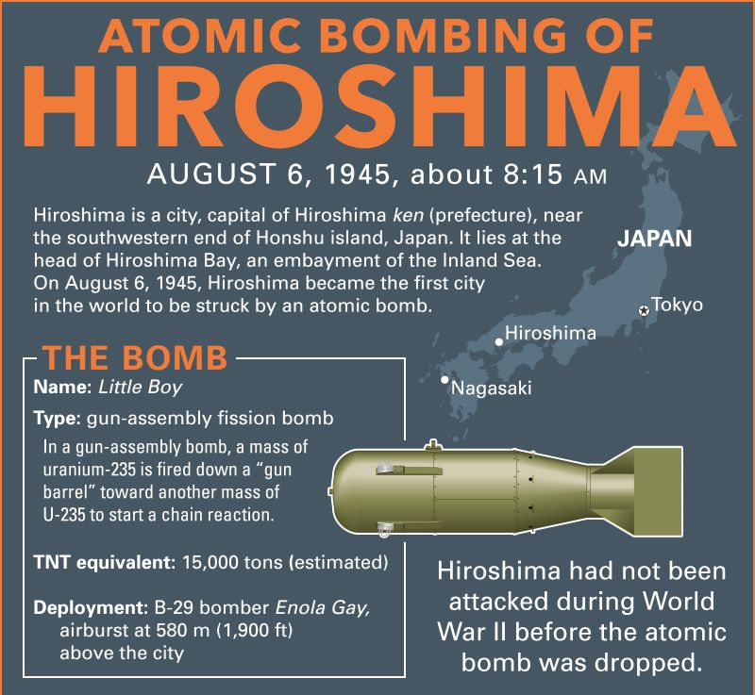

Building the United Nations

Even as the alliance frayed, its architecture for peace was being built. Delegates from fifty nations met at the United Nations Conference on International Organization in San Francisco between April and June 1945, and the UN Charter was signed on 26th June 1945, entering into force on 24th October 1945 after ratification by the five permanent Security Council members and a majority of other signatories.

The Charter's central bargain was the Security Council: eleven members in 1945 (later expanded), with five permanent members: the United States, the United Kingdom, France, the Republic of China, and the Soviet Union, each holding a veto over substantive decisions. This was meant to guarantee that the organisation could never again pass sweeping resolutions against a great power's core interests, as the League of Nations occasionally attempted to its own detriment.

In practice, it meant that any one of the five great powers could paralyse the entire body the moment their interests diverged. By 1948, that paralysis is no longer theoretical: the Soviet Union has already exercised its veto more than a dozen times on questions ranging from the admission of new member states to the situation in Greece. The UN's early years also saw the establishment of the General Assembly (first session, London, January 1946), the International Court of Justice, and the initial machinery for what would become UN peacekeeping and mediation, tools that were first tested, imperfectly, in Indonesia, Kashmir, and Palestine, all discussed below.

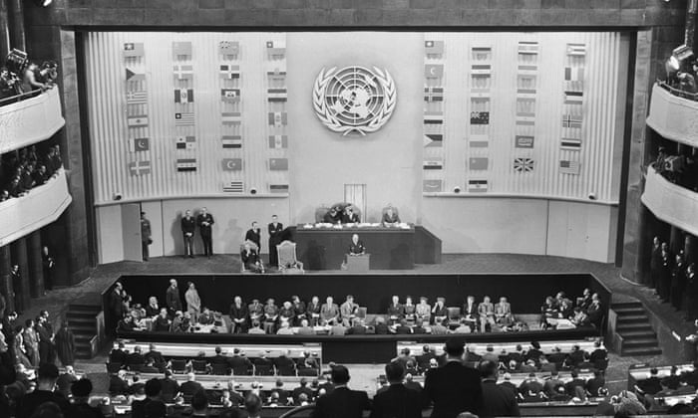

The Iron Curtain Descends

The first unmistakable public acknowledgement of the emerging divide came from a private citizen: Winston Churchill, no longer Prime Minister, delivered his “Sinews of Peace” address at Westminster College in Fulton, Missouri, on 5th March 1946, warning that “an iron curtain has descended across the Continent” from Stettin in the Baltic to Trieste in the Adriatic. The speech was controversial at the time, as Truman had not endorsed its content in advance but it named a division that was already hardening on the ground.

Two crises in 1946 confirmed the pattern. In Iran, Soviet troops that had jointly occupied the country with Britain during the war refused to withdraw by the agreed deadline of March 1946, instead backing short-lived separatist governments in Iranian Azerbaijan and Kurdistan; sustained diplomatic pressure at the United Nations Security Council, one of its first tests and direct US-Soviet negotiation eventually forced a Soviet withdrawal by May 1946. In Turkey, Soviet demands for joint control of the Turkish Straits and territorial concessions in eastern Anatolia (the “Turkish Straits crisis”) alarmed Washington enough that a US naval task force, headed by the battleship USS Missouri, was dispatched to the eastern Mediterranean in a show of support.

By early 1947, the pattern crystallised into policy. On 12th March 1947, President Truman addressed a joint session of Congress to announce what would be called the Truman Doctrine: a commitment to “support free peoples who are resisting attempted subjugation by armed minorities or by outside pressures,” with an immediate $400 million aid package aimed at Greece and Turkey. Three months later, on 5th June 1947, Secretary of State George Marshall proposed a sweeping programme of American economic aid to rebuild Europe, the European Recovery Program, or Marshall Plan which the Soviet Union and its Eastern European satellites were invited to join but ultimately refused, deepening the economic as well as political split of the continent. By the freeze date, the Marshall Plan is in its first year of disbursement, and Stalin has responded by tightening Moscow's grip on Eastern Europe (most dramatically through the communist coup in Czechoslovakia in February 1948) and by founding the Cominform in September 1947 to coordinate European communist parties against the “two camps” Soviet foreign policy now openly describes the world as divided into.

The Beginning of Decolonisation!

The war had shattered the prestige and the finances of the old European colonial empires, even as it had armed and organised millions of colonial subjects. The Philippines gained formal independence from the United States on 4th July 1946 - a rare peaceful transition, though one that left deep economic dependency and an unresolved land question that erupted into rebellion within weeks. India and Pakistan would gain independence on 14-15 August 1947 amid the largest mass migration and one of the bloodiest partitions in modern history. The Dutch East Indies, French Indochina and British Malaya all saw nationalist movements, some negotiating, some fighting, press for independence against colonial powers too exhausted to hold on by force alone, yet too invested to let go by choice. Every one of these transitions becomes, by 1948, a live crisis this committee must manage.

Conflicts Across the Globe

There are a lot of conflicts that have arisen post WW2: the collapse of the wartime alliance and the European empire, happening simultaneously on four continents, with the same great powers making decisions about all of them at once. We will delve into each of these conflicts briefly. The delegates are free to choose which conflicts they wish to prioritize, discuss and effectively resolve.

I. Germany

No crisis on this agenda is more directly the committee's business on the freeze date than this one. Occupied Germany was never meant to remain divided: the four occupying powers (the United States, the United Kingdom, France, and the Soviet Union) were supposed to administer it jointly through an Allied Control Council and eventually restore a unified, demilitarised German state. That plan collapsed almost as soon as it was tested.

Diverging occupation policies emerged quickly: the Soviets extracted reparations aggressively from their eastern zone (dismantling entire factories and shipping them east) and sponsored a Soviet-aligned administration, while the Western powers, increasingly worried about the economic and political cost of an impoverished, divided Germany, moved toward reconstruction. On 1st January 1947 the American and British zones merged into a single economic unit, “Bizonia”; the French zone would join in 1948 to create “Trizonia.” In March 1948, the Allied powers agreed to move toward a single West German economic administration and, crucially, toward introducing a new currency in the western zones which in turn steps the Soviet delegate on the Allied Control Council denounced as a violation of four-power agreements. The Soviet representative walked out of the Control Council on 20th March 1948, effectively ending joint governance of Germany.

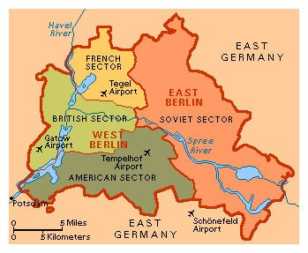

The currency crisis and the blockade

The trigger for outright confrontation was money. On 18th June 1948 the Western powers announced a currency reform introducing the Deutsche Mark in the western zones, effective 20th June. Moscow denounced this as an act of economic warfare designed to entrench the division of Germany, and on 23rd June announced its own currency reform for the Soviet zone. When the Western powers refused to accept the new Soviet currency in West Berlin and instead extended the Deutsche Mark to the city's western sectors from 25th June, the Soviet military administration responded by severing, in stages between 19th and 24th June, first passenger rail traffic and then all remaining road, rail, and canal links between West Berlin and the western occupation zones. By 24th June 1948, roughly 2.5 million residents of West Berlin, an island of Western-administered territory more than 160 kilometres inside Soviet-controlled eastern Germany were cut off from food, coal and medicine, with barely a month's reserves on hand.

Only the three air corridors agreed in the 1945-46 Air Agreement remained open, because Soviet forces had no legal basis to close them without unilaterally repudiating a separate agreement. On 26th June 1948, the United States launched Operation Vittles, the first American cargo flights of what would become known as the Berlin Airlift, landing at Tempelhof airfield; British aircraft (Operation Plainfare) began flying into Gatow within two days. At the point this committee opens, nobody yet knows whether an airlift can conceivably keep two and a half million civilians fed and warm through the coming winter (historically it did, continuing for 462 days until the blockade was lifted in May 1949), but on 26th June 1948 that success is entirely unproven, and the risk of the standoff escalating into direct military confrontation (the United States had already begun moving nuclear-capable B-29 bombers to British bases) is considered real by observers on every side.

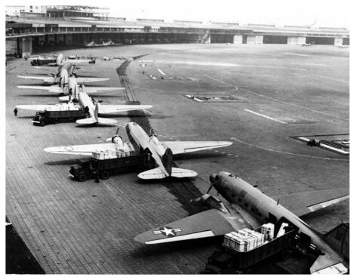

II. The Chinese Civil War

China's civil war between the Nationalist government of Chiang Kai-shek (the Kuomintang, or KMT) and the Chinese Communist Party (CCP) led by Mao Zedong had simmered, on and off, since the 1920s, interrupted by an uneasy united front against Japan during the Second World War. Renewed fighting broke out within months of Japan's surrender in 1945, despite American mediation efforts led by General George Marshall in 1946, which collapsed by the end of that year.

Through 1946 and into 1947, the numerically and materially superior Nationalist army, some five million men on paper, heavily supplied with American equipment left over from the Second World War appeared to hold the advantage, capturing the Communist wartime capital of Yan'an in March 1947. But Nationalist rule was undermined from within by hyperinflation, corruption, and the demoralisation of a war-weary population, while the Communists steadily out-organised the KMT at the local level, winning support through land redistribution and disciplined, popular administration in the areas they controlled. Communist forces also won a disproportionate share of smaller engagements even while losing the headline battles, capturing enough American-supplied weaponry from defeated or defecting Nationalist units that, by early 1948, Communist forces were in some respects better equipped than their opponents.
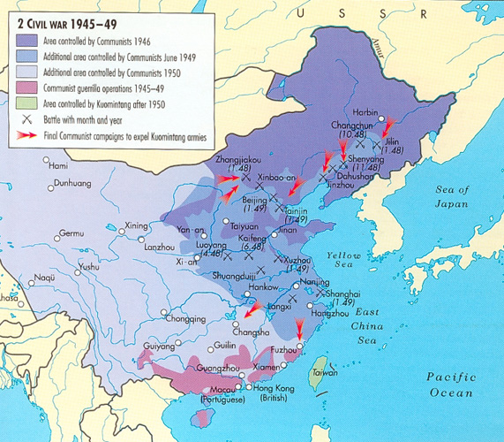

The Manchurian tipping point

Manchuria, which was China's most industrialised region, rich in coal, railways, and heavy industry, and the site of a prolonged campaign since April 1946 — became the decisive theatre. Lin Biao's Communist Northeast Field Army steadily isolated Nationalist garrisons in the region's major cities (Changchun, Mukden/Shenyang, Jinzhou) through 1947 and into 1948, resupplying them was only possible by air. By the freeze date, the Nationalist position in Manchuria is effectively surrounded and the initiative on every major front in China has passed to the Communists; the decisive Liaoshen campaign that will annihilate the Nationalist forces in Manchuria is still two months away (it begins 12th September 1948), but its outcome is already widely anticipated by informed observers in the summer of 1948.

On 1st September 1948, the Communists will proclaim the North China People's Government as a forerunner to a future national government: a step that, on the freeze date, has not yet happened but whose logic is already visible (which can also potentially be altered). For this committee, China represents the starkest instance of a great power (the United States) watching a client government lose a civil war in slow motion, with limited tools to reverse the trend short of far larger direct intervention than Washington has so far been willing to contemplate.

III. The Greek Civil War

Greece's civil war is arguably the conflict that gave the Cold War its name in practice, if not yet in phrase. Fighting had flared as early as December 1944, when British troops clashed with the communist-dominated resistance movement ELAS in Athens even before the war in Europe had ended (Dekemvriana). A fragile settlement broke down by 1946, and full-scale guerrilla war resumed between the royalist Greek government, backed first by Britain and then by the United States and the communist-led Democratic Army of Greece (DSE), the military wing of the Greek Communist Party (KKE), which by late 1947 had proclaimed a rival Provisional Democratic Government in the northern mountains.

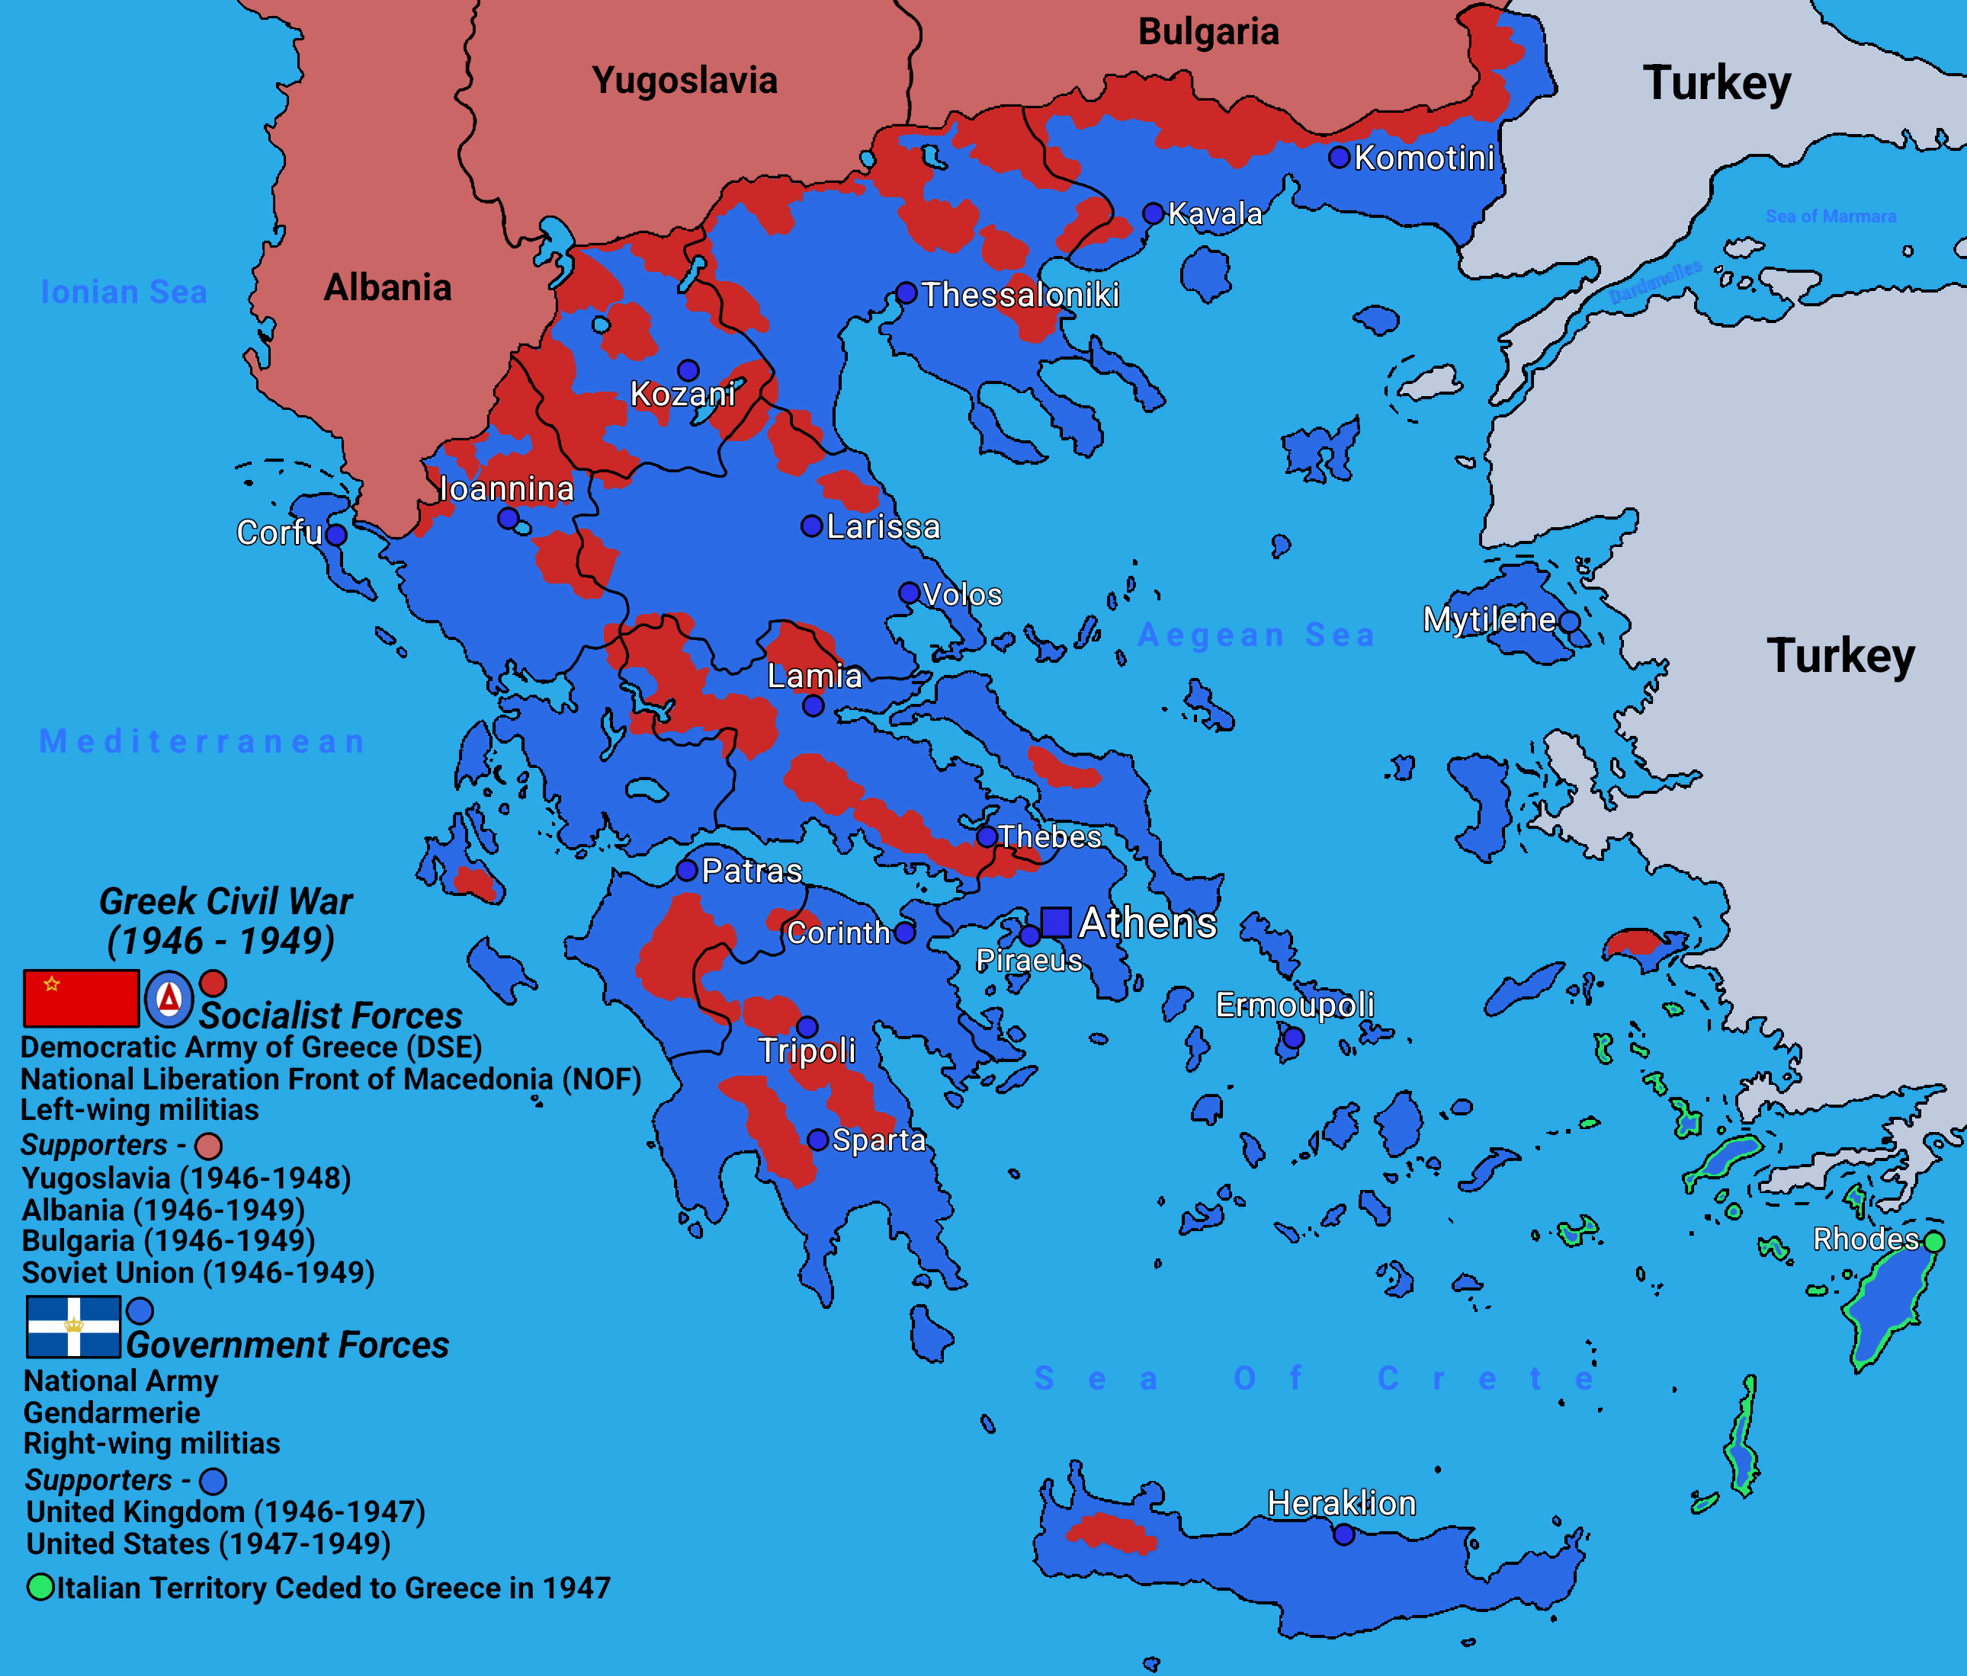

Britain's announcement in early 1947 that it could no longer afford to bankroll the Greek government's war effort directly precipitated the Truman Doctrine speech of 12th March 1947, making Greece the first place the United States committed itself to the containment of communism by material and financial support rather than colonial administration or direct combat. American aid rebuilt and re-equipped the Greek National Army through 1947 and into 1948.

On the ground in the summer of 1948, the war's centre of gravity is the mountain stronghold of Grammos in Epirus, on the border with Albania, where the DSE under its commander Markos Vafiadis has built an elaborate fortified line. A major government offensive against Grammos (subsequently known as Operation Koronis) opens in mid-June 1948, essentially concurrent with the freeze date, and will grind on until August without fully destroying the DSE's forces, which will fall back to a second stronghold at Vitsi.

The war's eventual turning point, the June 1948 rupture between Stalin and Yugoslavia's Josip Broz Tito (the Tito-Stalin split, publicly confirmed by the Cominform's expulsion of the Yugoslav party on 28th June 1948, essentially the moment this committee opens) will progressively cut off the DSE's most important external supply line and sanctuary, since Yugoslavia had been its principal backer. On the freeze date, however, this rupture is only just beginning, and its long-term consequences for the DSE are not yet apparent to the delegates.

IV. A Subcontinent divided

British India's independence on 15th August 1947 was accompanied by Partition: the division of the subcontinent into the Dominions of India and Pakistan along broadly religious lines and by one of the largest and most violent mass migrations in history, with an estimated ten to fifteen million people crossing the new border and communal violence killing hundreds of thousands. The princely states, semi-autonomous territories under indirect British rule, were left to accede to either new dominion, or in theory to remain independent.

The princely state of Jammu and Kashmir presented the sharpest problem: a Hindu Maharaja, Hari Singh, ruling a Muslim-majority population, strategically wedged between both new states. Hari Singh initially sought to remain independent. On 22nd October 1947, armed tribal lashkar fighters from Pakistan's North-West Frontier, reportedly with covert Pakistani logistical support, invaded Kashmir, advancing rapidly toward the capital Srinagar. facing collapse, Hari Singh signed an Instrument of Accession to India on 26th October 1947, and Indian troops were airlifted into Srinagar from 27th October, transforming what had begun as a tribal incursion into open war between the armies of the two new dominions. This has caused the accession of Kashmir to India to be contested.

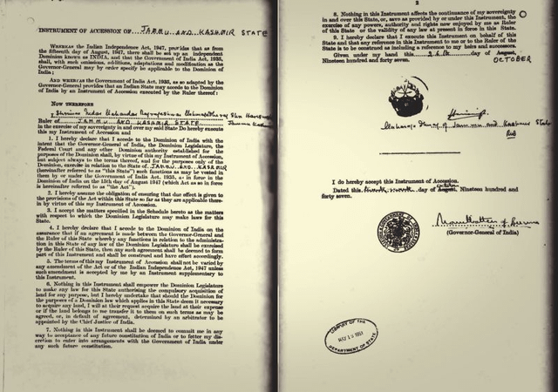

Internationalisation and stalemate

India brought the dispute to the United Nations Security Council on 1st January 1948, accusing Pakistan of aggression; Pakistan countered that India's accession was itself illegitimate and raised its own grievances over the princely state of Junagadh (where a Muslim ruler had acceded to Pakistan despite a Hindu-majority population, before India annexed it by force) and over communal violence against Muslims. The Security Council passed Resolution 39 in January 1948 establishing the UN Commission for India and Pakistan (UNCIP) and, in April 1948, Resolution 47, calling for a Pakistani troop withdrawal, a plebiscite under UN supervision, and phased demilitarisation, terms neither side has fully accepted by the freeze date.

On the ground, by June 1948 the war has settled into a rough, roughly one-third-Pakistan/two-thirds-India partition of the state along a front line that neither side is fully able to shift, with the war continuing (it will not end until a UN-brokered ceasefire takes effect on 1st January 1949, roughly along what becomes the modern Line of Control). For this committee, Kashmir is the first case in which a newly independent, non-Western state has taken a dispute to the Security Council and received a structured but unenforceable set of resolutions. The fate of Kashmir can be decided with a few precise and delicate steps.

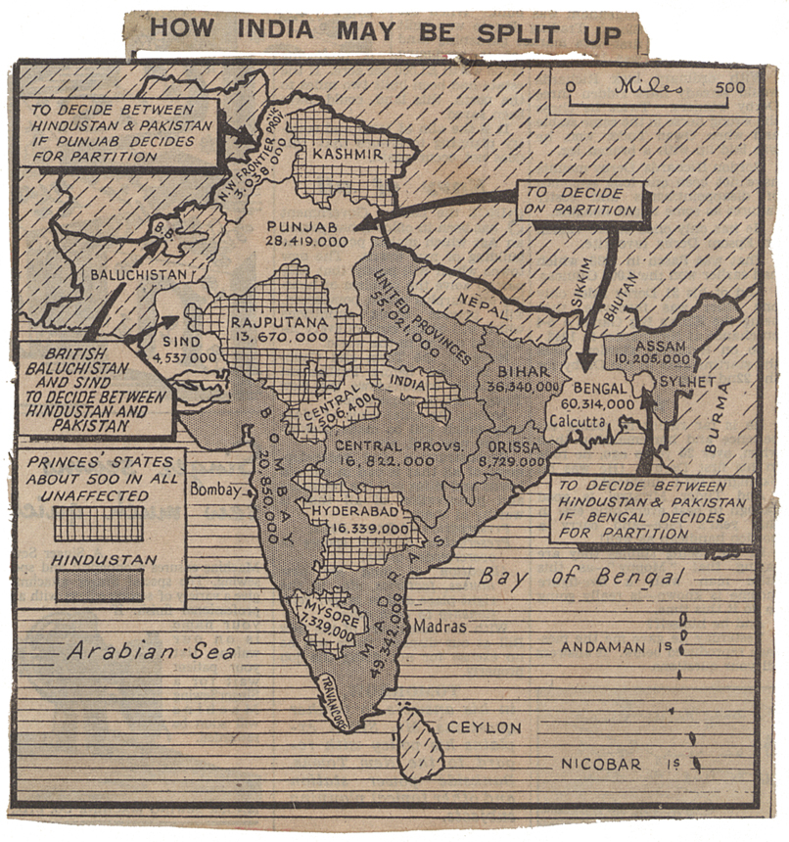

V. The Indonesian National Revolution

The Dutch East Indies had been under Japanese occupation since 1942. Two days after Japan's surrender, nationalist leaders Sukarno and Mohammad Hatta proclaimed the independence of the Republic of Indonesia on 17th August 1945. The Netherlands, seeking to restore its colonial rule, refused to recognise the proclamation, and a mixed war of diplomacy and armed conflict, the Indonesian National Revolution has continued since.

From Linggadjati to Renville

An initial accord, the Linggadjati Agreement of November 1946, saw the Netherlands provisionally recognise Republican authority over Java, Sumatra and Madura, envisioning an eventual federal “United States of Indonesia” still linked to the Dutch Crown. The agreement collapsed within months amid mutual accusations of violation, and in July 1947 the Netherlands launched a major military offensive (“Operation Product,” termed a “police action” by The Hague) that seized large areas of Republican-held territory, particularly plantation and resource-rich regions of Java and Sumatra. International reaction, including a Security Council resolution passed on 1st August 1947 at Australia's initiative calling for a ceasefire, and the involvement of a UN-appointed Good Offices Committee of the United States, Australia, and Belgium pushed both sides back to the table.

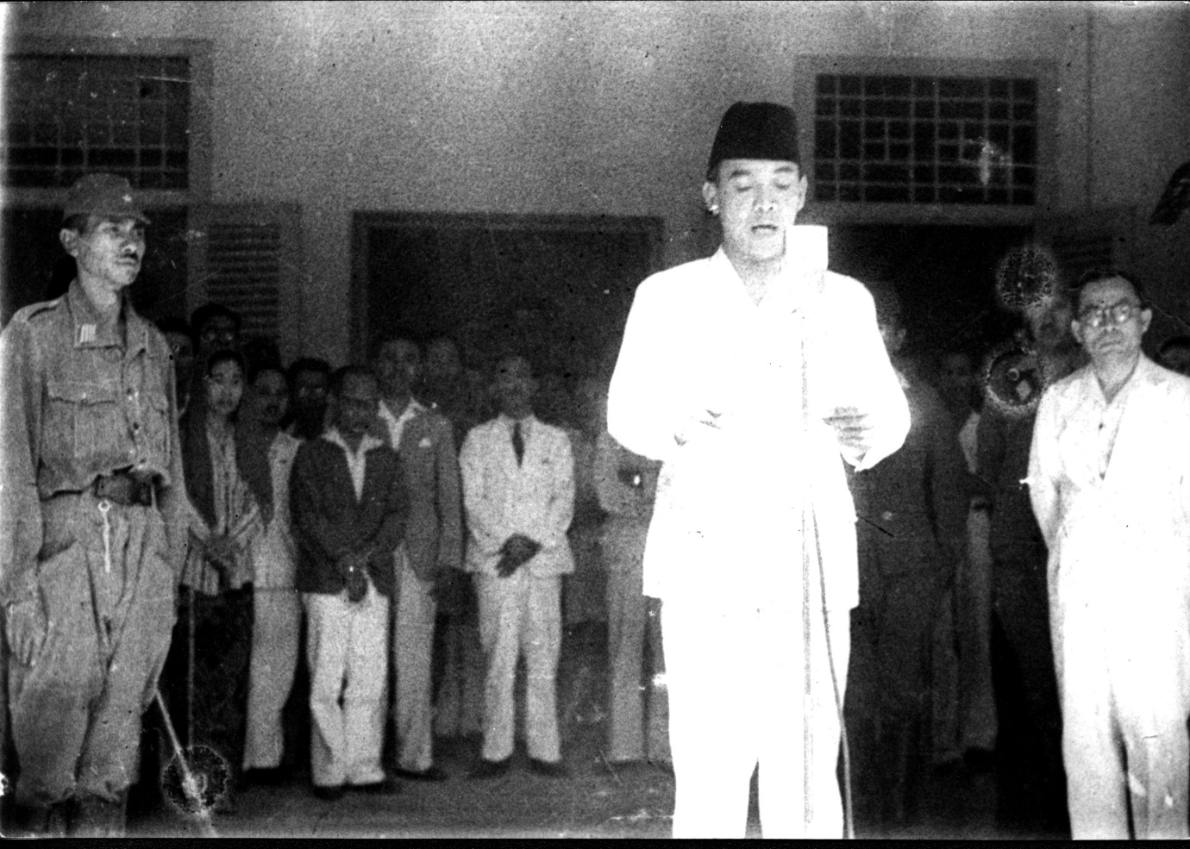

Negotiations aboard the American transport ship USS Renville, anchored in Jakarta Bay, produced the Renville Agreement, ratified 17th January 1948. It recognised a ceasefire along the so-called Van Mook Line (marking the furthest Dutch advances) and set out principles for an eventual plebiscite and federal settlement, but left the most contentious issues: territory, sovereignty and the timeline to full independence remained unresolved. The Agreement proved deeply unpopular within the Republic, precipitating a cabinet crisis that brought down the Amir Sjarifuddin government in January 1948 and installed a new cabinet under Mohammad Hatta.

By the freeze date, the Renville ceasefire line technically holds, but each side accuses the other of violations, Dutch-sponsored federal states (such as the State of East Sumatra and the State of Pasundan) continue to be established inside Republican-claimed territory in what the Republic regards as an attempt to encircle and delegitimise it, and a UN Consular Commission and a Committee of Good Offices continue monitoring compliance without enforcement power.

Internally, the Republic is also managing a serious left-wing challenge: a communist-led uprising centred on the town of Madiun will break out in September 1948, just months away reflecting deep divisions within the nationalist movement over how far to align with Moscow versus the non-aligned, negotiated path favoured by Sukarno and Hatta. None of this is yet visible on the freeze date, but the tension feeding it is. Historically, the truce collapses entirely in December 1948, when the Netherlands launches a second, larger “police action” and captures the Republican capital, Yogyakarta, an event still four months away from this committee's opening, and very much within its power to prevent, provoke, or ignore.

VI. The Philippine Hukbalahap Rebellion

The Philippines gained formal independence from the United States on 4th July 1946, but for the peasant farmers of Central Luzon, independence changed remarkably little. The Hukbalahap (“Hukbo ng Bayan Laban sa Hapon,” or People's Anti-Japanese Army) had been the most effective guerrilla resistance movement against Japanese occupation, built substantially on the grievances of tenant farmers against absentee landlords. When the war ended, returning landlords, often the same families that had collaborated with the Japanese occupation reclaimed their estates and, in many cases, demanded back rent from tenants who had barely survived the occupation.

From electoral fraud to armed uprising

Huk-aligned candidates won seats in the 1946 congressional elections on a platform of land reform, but the Philippine Congress, under President Manuel Roxas, refused to seat them, alleging electoral fraud, a decision whose legitimacy is still bitterly disputed and which removed the last plausible peaceful avenue for the movement's demands. Sporadic violence escalated into open conflict; the kidnapping and murder of the prominent peasant leader Juan Feleo in August 1946 is often cited as a proximate trigger. Hukbalahap commander Luis Taruc, denied his congressional seat, went underground by early 1947, and the movement rearmed as the Hukbong Mapagpalaya ng Bayan (People's Liberation Army), continuing to be popularly known as the Huks.

The Philippine government formally outlawed the Hukbalahap and the allied Communist Party of the Philippines (PKP) in March 1948. Intermittent negotiations over amnesty and disarmament continued through the spring, but by June 1948, precisely the freeze date, these talks have broken down for the latest time, consistently foundering on the same question: the government demands the Huks surrender their weapons before any political settlement, while the Huks (having watched previous surrenders end in arrests and assassinations of their cadres) refuse to disarm without prior guarantees of land reform and amnesty.

Neither side, on the freeze date, has the numbers or momentum that will define the conflict's most dangerous phase, the Huk movement will not reach its peak strength and territorial control until around 1950, when it will come close to threatening the stability of the Philippine state itself, before a combination of American-backed counter-insurgency reform under Ramon Magsaysay and targeted land concessions breaks the rebellion's momentum by the mid-1950s. On the freeze date, this trajectory is still avoidable, and the choices made in mid-1948: on amnesty, on land reform, on the degree of American security assistance, will shape whether Manila faces a containable insurgency or a near-existential one.

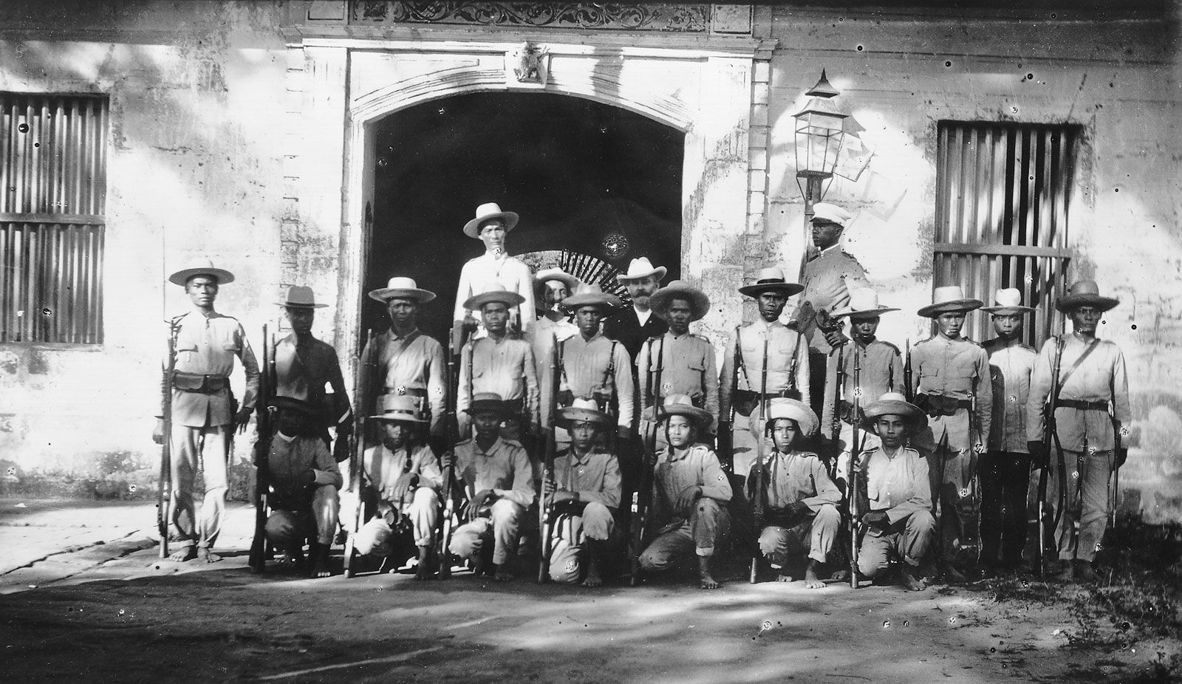

VII. The First Arab-Israeli War

The British Mandate for Palestine, administered since 1920, had become unworkable by the mid-1940s in the face of rising Jewish immigration (intensified by the Holocaust and the plight of Jewish refugees across Europe) and Arab Palestinian opposition to the prospect of a Jewish state. Britain referred the question to the United Nations, and on 29th November 1947 the UN General Assembly adopted Resolution 181, recommending the partition of Palestine into separate Jewish and Arab states with Jerusalem under international administration. Jewish leadership broadly accepted the plan; Arab and Palestinian leadership rejected it, and civil war between Jewish and Arab communities inside Palestine broke out almost immediately, months before any formal state existed.

Declaration and invasion

As the British Mandate formally expired, Jewish leaders proclaimed the State of Israel on 14th May 1948. Within hours, the armies of Egypt, Transjordan, Syria, Lebanon and Iraq, joined by irregular forces and, in Egypt's case, Saudi troops under Egyptian command invaded, aiming to prevent the new state's consolidation. Fighting through May 1948 saw dramatic reversals across multiple fronts: the Jewish Quarter of Jerusalem's Old City fell to Transjordan's British-officered Arab Legion on 28th May after a bitter siege, even as Israeli forces held and expanded a corridor connecting Tel Aviv to the western part of the city; Egyptian forces advanced along the coast and through the Negev toward Beersheba before being slowed by determined Israeli resistance; Syrian and Iraqi offensives in the north and centre stalled into rough stalemates by early June.

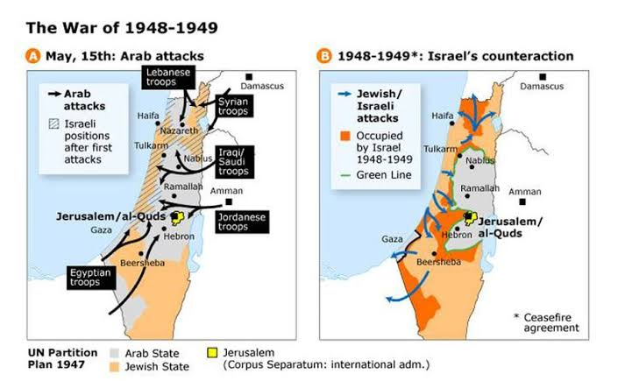

Bernadotte's truce

On 20th May 1948, UN Secretary-General Trygve Lie appointed the Swedish diplomat Count Folke Bernadotte as UN Mediator for Palestine, following a General Assembly decision on 14th May. After weeks of shuttle diplomacy, the UN Security Council secured agreement to a first truce, which took effect on 11th June 1948 and was intended to last twenty-eight days. On the freeze date, this truce has been in force for barely two weeks: fighting has formally stopped, but each side is using the pause to reorganise. Israel's Prime Minister David Ben-Gurion is using the lull to bring the country's various Jewish paramilitary factions: the Haganah, the Irgun, and Lehi, under the unified command of the newly formed Israel Defense Forces, a process not yet complete and complicated, within days of the freeze date, by the Altalena affair (20th June 1948), in which a ship carrying Irgun arms triggered an armed standoff with the fledgling IDF that killed sixteen Irgun fighters and threatened to split the new state's forces before the crisis was contained.

Arab governments, meanwhile, are rearming and repositioning, and most observers on the ground expect the truce to be temporary rather than a genuine step toward peace, a judgement events will vindicate: fighting resumes on 8-9 July 1948 once the truce expires, followed by a second truce from 18th July, and full-scale war resumes again in October 1948 before a series of 1949 armistice agreements (not covered by this committee's timeline) finally end the fighting without a comprehensive peace. On the freeze date, Bernadotte is actively working on proposals to revise the original partition boundaries, essentially the proposals that contribute, tragically, to his assassination by Lehi militants in Jerusalem in September 1948, an event still three months away.

VIII. The First Indochina War

French Indochina which is a combination of modern day Vietnam, Laos, and Cambodia, had been administered by Vichy French officials under Japanese military oversight through most of the Second World War, before Japan's outright takeover of direct administration in March 1945. On 2nd September 1945, the very day of Japan's formal surrender the Viet Minh (the Vietnamese nationalist and communist-led independence movement founded by Ho Chi Minh in 1941) proclaimed the independence of the Democratic Republic of Vietnam in Hanoi. France, determined to restore its colonial position, moved troops back into the south in late 1945 and negotiated an uneasy modus vivendi with the Viet Minh in the north through most of 1946, recognising Vietnam as a “free state” within the French Union in a March 1946 accord that neither side ultimately honoured in full.

The road to war: Haiphong and Hanoi

Tensions over customs control in the northern port city of Haiphong escalated in November 1946; on 23rd November, French naval and artillery bombardment of the city killed an estimated six thousand Vietnamese civilians. The Viet Minh responded on 19th December 1946 with a coordinated uprising and attack on French positions across Hanoi, marking the conventional start of the First Indochina War. French forces, though initially caught off-guard, drove the Viet Minh out of Hanoi and the other major cities by early 1947, forcing Ho Chi Minh's government to retreat into the mountainous Viet Bac region in the north, from which it has directed a protracted guerrilla campaign ever since.

The Bao Dai gambit

Unable to defeat the Viet Minh outright and unwilling to grant full independence, France pursued a parallel political strategy from 1947 onward: cultivating the former Vietnamese emperor, Bao Dai, as the head of an alternative, France-aligned Vietnamese state that could claim nationalist legitimacy without the Viet Minh's communist politics. Negotiations with Bao Dai progressed through 1948; a preliminary accord (the Ha Long Bay agreement, signed 5th June 1948, just three weeks before the freeze date) has France recognising Vietnamese independence “within the French Union” under Bao Dai in principle, though the fuller Elysee Accords formalising the State of Vietnam will not be signed until March 1949.

On the freeze date, the Viet Minh controls most of the countryside and enjoys genuine popular legitimacy as the movement that resisted both Japan and France, while French and French-aligned forces hold the cities and major transport routes, a division of control that will persist, essentially unresolved, until the decisive French defeat at Dien Bien Phu in 1954. For the great powers on this committee, Indochina in mid-1948 is not yet framed primarily in Cold War term, that reframing, with active Chinese Communist and then American involvement, intensifies after the Chinese Communist victory in 1949, but the ideological alignment of the Viet Minh with international communism is already a growing concern in Washington.

IX. Afghanistan and Pakistan

Unlike the other conflicts on this agenda, the Afghan-Pakistan dispute has not yet produced open warfare by the freeze date, but it is a live and hardening diplomatic rupture with long-term implications for regional stability, and it deserves careful attention precisely because it is still a matter of choice rather than momentum.

The Durand Line, a roughly 2,600-kilometre border demarcated in 1893 by British diplomat Sir Mortimer Durand and the Afghan Emir Abdur Rahman Khan, divided British India from Afghanistan and, in doing so, divided the Pashtun ethnic population, splitting families, tribes, and traditional migratory routes between what is today north-western Pakistan and southern and eastern Afghanistan. When Pakistan emerged as an independent state in August 1947, it inherited this boundary as a matter of state succession under international legal practice. Afghanistan, however, immediately disputed its legitimacy, arguing that the original agreements had been concluded with British India rather than with Pakistan, and that Pashtun populations along the frontier should be entitled to a genuine choice about their political future rather than automatic incorporation into the new Pakistani state.

The Bannu Resolution and the referendum dispute

The dispute has a direct root in the referendum process that determined the fate of the North-West Frontier Province before Partition. Khan Abdul Ghaffar Khan, the prominent Pashtun nationalist leader of the non-violent “Red Shirt” (Khudai Khidmatgar) movement and a close ally of the Indian National Congress, opposed Partition outright and demanded that Pashtuns be offered a genuine third option, an independent Pashtunistan rather than a binary choice between joining India or Pakistan. When this demand was refused, Ghaffar Khan's movement boycotted the July 1947 referendum on the province's accession, which consequently returned an overwhelming vote for Pakistan from a reduced electorate. On 21st June 1947, tribal representatives meeting at Bannu adopted what became known as the Bannu Resolution, formally demanding the right to choose an independent Pashtun state; this demand was not accommodated in the final Partition settlement.

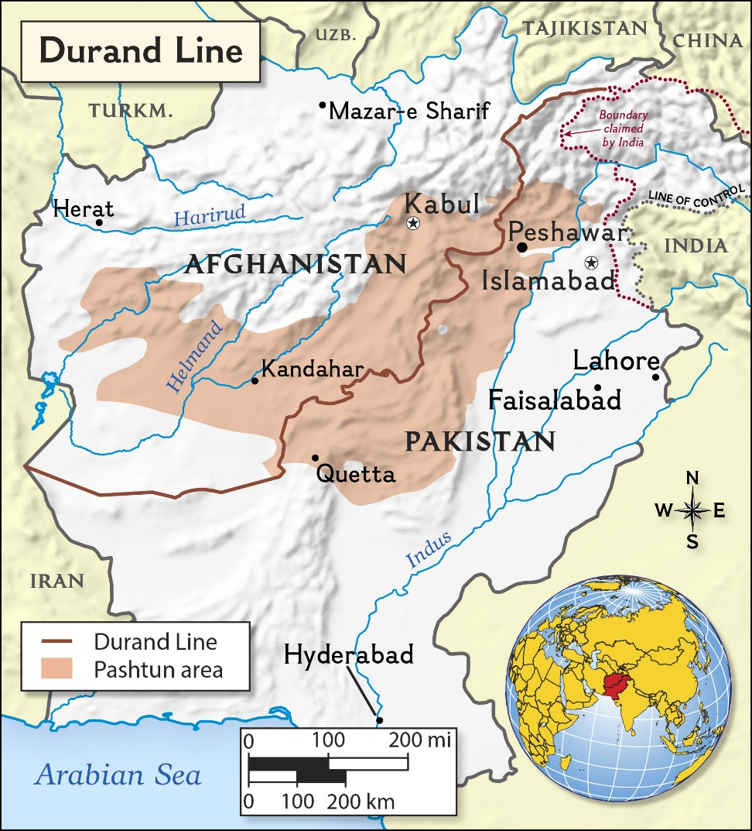

Where things stand on the freeze date

Afghanistan cast the only vote in the UN General Assembly against Pakistan's admission to the United Nations, citing the unresolved status of the Durand Line and of the Pashtun territories. Through late 1947 and into 1948, the Afghan government has continued to press the “Pashtunistan” question diplomatically, sponsoring or tolerating cross-border agitation among Pashtun tribes on the Pakistani side of the line, while Islamabad regards any discussion of the border's legitimacy as an existential threat to its territorial integrity in a region it has only just inherited from British India.

On the freeze date, no fighting has occurred and no formal rupture in diplomatic relations exists, but mutual suspicion is deep, tribal areas along the frontier remain only loosely administered by either state, and this committee's great powers, several of which have their own strategic interests in South and Central Asia, must decide whether and how to engage with a dispute that neither Kabul nor Karachi shows any inclination to resolve through negotiation. Left unaddressed, this dispute will recur as a source of tension between Afghanistan and Pakistan for decades to come.

Timeline of Events

Date | Location | Event
6 Aug 1945 | Global / Japan | The United States drops an atomic bomb on Hiroshima.
8-9 Aug 1945 | Asia-Pacific | The USSR declares war on Japan and rapidly overruns Manchuria and northern Korea; the US drops a second atomic bomb on Nagasaki.
2 Sep 1945 | Global | Japan formally surrenders aboard the USS Missouri, ending the Second World War.
2 Sep 1945 | Indochina | Ho Chi Minh proclaims the Democratic Republic of Vietnam in Hanoi.
Oct 1945 | Global | The United Nations Charter enters into force (24 Oct) after ratification.
Nov 1945 - Oct 1946 | Europe | The Nuremberg Trials of major Nazi war criminals are conducted.
17 Aug 1945 | Indonesia | Sukarno and Hatta proclaim Indonesian independence, rejected by the Netherlands.
Jan 1946 | Global | First session of the UN General Assembly convenes in London.
Mar 1946 | Europe | Winston Churchill delivers his “Iron Curtain” speech at Fulton, Missouri.
Mar-May 1946 | Iran | Soviet troops delay withdrawal from northern Iran; crisis resolved via UN pressure.
23 Nov 1946 | Indochina | French naval bombardment of Haiphong kills an estimated 6,000 civilians.
19 Dec 1946 | Indochina | Viet Minh attacks on Hanoi mark the conventional start of the First Indochina War.
Nov 1946 | Indonesia | Linggadjati Agreement provisionally recognises Republican authority over Java, Sumatra, Madura.
4 Jul 1946 | Philippines | The Philippines gains formal independence from the United States.
24 Aug 1946 | Philippines | Peasant leader Juan Feleo is kidnapped and killed; Huk–government tensions escalate toward armed conflict.
12 Mar 1947 | Global / Greece-Turkey | Truman Doctrine announced; US pledges support to Greece and Turkey against communist pressure.
Mar 1947 | China | Nationalist forces capture the Communist wartime capital, Yan'an.
21 Jun 1947 | Afghanistan–Pakistan | Tribal representatives adopt the Bannu Resolution, demanding a choice of Pashtun independence.
5 Jun 1947 | Europe | George Marshall proposes the European Recovery Program (Marshall Plan).
Jul 1947 | Indonesia | The Netherlands launches “Operation Product,” a major military offensive against the Republic.
1 Aug 1947 | Indonesia | UN Security Council calls for a ceasefire between Dutch and Republican forces.
14/15 Aug 1947 | South Asia | India and Pakistan gain independence amid Partition and mass communal violence.
Sep 1947 | Afghanistan–Pakistan | Afghanistan casts the sole vote against Pakistan's admission to the United Nations.
Sep 1947 | Global | The Soviet Union and allied parties found the Cominform, declaring a world of “two camps.”
22 Oct 1947 | Kashmir | Tribal lashkar forces from Pakistan invade Kashmir, triggering the First Kashmir War.
26 Oct 1947 | Kashmir | Maharaja Hari Singh signs the Instrument of Accession to India; Indian troops airlift into Srinagar.
29 Nov 1947 | Palestine | UN General Assembly Resolution 181 recommends the partition of Palestine.
Dec 1947 | China | Communist forces launch a major winter offensive; Nationalist position begins to erode markedly.
1 Jan 1948 | Kashmir | India brings the Kashmir dispute to the UN Security Council.
17 Jan 1948 | Indonesia | The Renville Agreement is ratified, establishing a fragile truce line.
Feb 1948 | Europe | Communist coup consolidates power in Czechoslovakia, alarming Western capitals.
Mar 1948 | Philippines | The Philippine government formally outlaws the Hukbalahap and the Communist Party (PKP).
Mar 1948 | Europe / Germany | Allied powers agree to move toward a unified West German administration; the Soviet delegate walks out of the Allied Control Council (20 Mar).
Apr 1948 | Kashmir | UN Security Council Resolution 47 calls for troop withdrawal and a plebiscite.
1 Apr 1948 | Europe / Germany | The Soviet Union begins restricting Allied road and rail traffic to Berlin as a first pressure tactic (the “baby blockade”).
3 Apr 1948 | Global | US President Truman signs the Marshall Plan into law.
14 May 1948 | Palestine | The State of Israel declares independence; neighbouring Arab states invade within hours.
20 May 1948 | Palestine | Count Folke Bernadotte is appointed UN Mediator for Palestine.
28 May 1948 | Palestine | Transjordan's Arab Legion captures the Jewish Quarter of Jerusalem's Old City.
5 Jun 1948 | Indochina | France and Bao Dai sign the preliminary Ha Long Bay agreement.
11 Jun 1948 | Palestine | A UN-brokered First Truce takes effect in the Arab–Israeli War.
14 Jun 1948 | Greece | Government forces launch a major offensive (Operation Koronis) against DSE positions at Grammos.
18 Jun 1948 | Europe / Germany | Western Allies announce currency reform, introducing the Deutsche Mark in their occupation zones.
19-20 Jun 1948 | Palestine | The Altalena affair: an armed standoff over an Irgun arms shipment threatens the unity of Israel's new armed forces.
19-24 Jun 1948 | Europe / Germany | The Soviet military administration progressively severs rail, road, and canal links to Berlin.
23 Jun 1948 | Europe / Germany | The Soviet Union announces its own currency reform for the eastern zone and East Berlin.
24 Jun 1948 | Europe / Germany | All remaining surface routes into West Berlin are cut; the Berlin Blockade formally begins.
25 Jun 1948 | Europe / Germany | The Western powers extend the Deutsche Mark to the western sectors of Berlin.
26 Jun 1948 | Europe / Germany | The United States launches Operation Vittles, the first flights of the Berlin Airlift, landing at Tempelhof. Committee begins.

The Current Situation

- Germany: In Berlin, the first American cargo aircraft of Operation Vittles are being cleared to fly from air bases in the western zones of Germany to Tempelhof airfield in the American sector of the city. British aircraft under Operation Plainfare will begin similar flights into Gatow within forty-eight hours.
- China: Communist forces hold the strategic initiative across almost every front; Nationalist garrisons in Manchuria are increasingly isolated and dependent on air resupply. The decisive Liaoshen campaign is roughly eleven weeks away, though not yet begun.
- Greece: A major government offensive against the Democratic Army of Greece's Grammos stronghold has just opened (14th June). Within days, the Cominform will publicly expel Yugoslavia; a rupture whose consequences for the DSE's external support are not yet apparent to contemporaries.
- Kashmir: War continues at a rough stalemate along a front line neither side can substantially shift; a UN Security Council resolution from April calling for withdrawal and plebiscite sits unimplemented.
- Indonesia: The Renville truce line technically holds, but each side accuses the other of violations, and Dutch-sponsored federal states are being established inside territory the Republic considers its own.
- Philippines: Amnesty and disarmament talks between the government and the outlawed Hukbalahap have just broken down again over the same unresolved sequencing dispute: arms first or reform first.
- Palestine: The First Truce, in effect since 11th June, is expected by most observers to be temporary; both sides are rearming and reorganising rather than negotiating a lasting peace. The Altalena crisis has just tested, and nearly broken, Israel's fragile unified command.
- Indochina: France and the former emperor Bao Dai have signed a preliminary accord recognising nominal Vietnamese independence within the French Union, while the Viet Minh continue to hold the countryside from their base in the Viet Bac.
- Afghanistan-Pakistan: No fighting has occurred, but diplomatic relations remain strained over the Durand Line and the unresolved Pashtunistan question, with cross-border agitation tolerated or encouraged by Kabul.

Conclusion

The post WW2 international order is entering a period in which several regional conflicts are beginning to interact with the emerging rivalry between the major powers. The immediate crisis in Berlin is the most acute, with the Soviet blockade having cut the western sectors of the city off from surface access while the United States has just begun Operation Vittles. At the same time, China is moving toward a decisive phase of its civil war, the Greek Civil War is intensifying around Grammos, India and Pakistan remain locked in an unresolved conflict over Kashmir, and the Indonesian and Indochinese independence struggles continue to challenge European colonial authority. Palestine remains under a fragile UN brokered truce, while the dispute between Afghanistan and Pakistan has yet to become an armed conflict but is already generating serious diplomatic tensions.

These crises should not be viewed as isolated disputes. The same major powers are simultaneously providing military, economic, political or diplomatic support across several theatres, while the United Nations is still developing practical mechanisms for managing conflicts involving competing great power interests. The central challenge before the committee is therefore not simply to react to individual conflicts, but to determine how far international diplomacy can prevent local disputes from becoming wider confrontations. The Executive Board suggests that the committee is intended to operate at precisely the point where alternative diplomatic, political, economic and strategic decisions can still alter the subsequent course of these crises.

Relevant International Framework

- Charter of the United Nations
- Geneva Conventions (1949)
- General Assembly Resolution 181 (II), Future Government of Palestine
- Security Council Resolution 39, 47 (1948), Kashmir
- Security Council resolutions concerning the Indonesian question, 1947-1948
- Security Council resolutions concerning the Palestine question, 1947-1948
- Potsdam Agreement
- Yalta Conference agreements concerning Germany and Berlin, February 1945
- Declaration Regarding the Defeat of Germany and the Assumption of Supreme Authority with Respect to Germany, 5 June 1945
- Agreement on the Zones of Occupation in Germany and the Administration of Greater Berlin, 12 September 1944
- 1945 Allied agreements concerning air corridors and access to Berlin
- General Assembly Resolution 41 (I), The Question of the Restoration of the Full Rights of China
- Sino-Soviet Treaty of Friendship and Alliance, 14 August 1945
- Constitution of the Republic of China, 1947
- Security Council Resolution 15, 17, 34 (1946/1947), Greek Question
- Truman Doctrine
- Treaty of Peace with Bulgaria
- Instrument of Accession of Jammu and Kashmir to India, 26 October 1947
- United Nations Commission for India and Pakistan proposals concerning demilitarisation and plebiscite
- Linggadjati Agreement, 15 November 1946
- Renville Agreement, 17 January 1948
- United Nations Good Offices Committee framework
- Philippine Independence Act / Tydings-McDuffie Act, 1934
- Philippines-United States Military Assistance/Bases Agreements, 1947
- Philippine Government legislation concerning the Hukbalahap and Communist Party
- General Assembly Resolution 186 (S-2), appointment of the United Nations Mediator
- Relevant Arab-Israeli armistice and truce arrangements existing as of 26 June 1948
- Ho-Sainteny Agreement, 6 March 1946
- Modus Vivendi between France and Vietnam, 14 September 1946
- Ha Long Bay Agreement, 5 June 1948
- Durand Agreement, 12 November 1893
- Anglo-Afghan Treaty of 1919, 1921
- Indian Independence Act, 1947
- Bannu Resolution, 21 June 1947
- Mountbatten Plan, Marshall Plan / European Recovery Program

Crisis Rules of Procedure

What can you do?

Military Operations
The careless or unnecessary deployment of troops is strongly discouraged. We urge delegates to recognize that in the current circumstances, a judicious use of all available resources is imperative. Every course of action should be carefully considered, taking into account its feasibility and potential consequences.

Intelligence or Covert Operations
These operations will serve as your primary method of gathering intelligence and shaping the strategic environment. Typically, they involve covert actions that would be "publicly condemned." The interpretation of what this entails is flexible, but the goal remains to gain a competitive advantage for your committee. We strongly advise delegates to thoroughly review these directives multiple times to ensure there are no exploitable loopholes that others could use to their benefit. Successful intelligence operations could potentially give you the edge for winning the committee.

Internal Actions
All internal actions, whether economic, political, or social, must also be executed through formal directives. These can range from providing food aid to reallocating funds or enhancing internal security. However, we remind delegates that just because these actions take place within your country, it does not guarantee approval. The final decision rests with the Executive Board, which retains discretion over whether to pass these directives.

Documentation

Directive

A directive is a type of written instruction or action plan used primarily in crisis committees or specialized bodies, where the debate focuses on real-time crises. Directives allow delegates to respond quickly to unfolding events by suggesting or ordering specific actions to address the situation.

They serve as a tool for the committee to resolve issues or handle emergencies. They can pertain to military, diplomatic, economic, or covert operations, depending on the nature of the committee. Directives can be sent in by an individual delegate or by a group of delegates. When sent in by a group of delegates, it is called a joint directive.

Overt Directive
All directives are by default considered overt in nature (especially in such a case where the type of directive is not mentioned). Information on both the execution and outcome of such a directive shall be communicated to the committee.

Covert Directive
A covert directive can be used by delegates to secretly to achieve their objectives without revealing their actions to the entire committee. These directives are confidential and often involve intelligence gathering, espionage, sabotage, or other behind-the-scenes operations.

The goal of a covert directive is to influence the outcome of the crisis without the knowledge or approval of other delegates. If an action is conspicuous and cannot be carried out covertly, it would not matter if it was enclosed within a covert directive, its execution and outcome will be communicated to the entire committee.

Communiqué
Communiqués are messages from the entire committee/delegate to another country, organization, person or group of people. These facilitate dialogue with relevant actors in a crisis.

Communiqués often include negotiations, threats, and requests for aid or support but are not limited to the above stated. They are usually utilized when a country whose consent, opinion, or stance on a particular issue is required, but whose representation does not exist in committee.

Covert Communiqué
It is of the same nature as a communiqué except that all communication is kept private between the delegate(s) and the recipient(s) involved. The only exception being that if any action cannot be carried conspicuously, then it will eventually be revealed to the committee.

Press releases
These are public statements that the delegate(s) want their government(s) to issue. These can be sent in by individual delegates or a group of delegates. If passed, these shall be publicly displayed in the committee. A Press Release cannot be used to make a statement unless a related directive/update contextually precedes it.

Portfolio Requests
These are communications from individual delegates to their respective governments seeking information unavailable to them at the moment based on which they can decide to take action. Such requests are encouraged only when the information sought is publicly unavailable.

Portfolio requests are requests given unilaterally by members of the committee. This could range anywhere between the status of their military capabilities to action taken by the delegate in accordance with their portfolio in previous conflicts/events*. The Executive Board will not entertain portfolio requests requesting random pieces of information that would not be viable to present as a response.

*Specific to those mentioned in the timeline and which have not been expanded upon.

Format

To: The Executive board
From: “XYZ Country”
Covert / Overt Directive / Portfolio Request / Communiqué
Primary Objective:
Secondary Objective: (Optional)
Mission Brief: (The details of the operation in a brief manner)
Plan of Action:
(This should be listed in the form of bullet points and should be detailed in nature so as to lay out the entire plan from start to finish. Ideally one should account for all possibilities and potential problems while drafting the points and address the same. This could potentially increase its rate of success.)
Personnel/Resources involved: (Optional)
Expected Outcome:
Signature: One signature from the representative is good enough. Whereas in case of a join directive, even if a single signature is missing then the directive will not be considered by the Executive Board.

Delegates need to note that updates will largely be based on the directives received, but not all directives will be converted into updates and displayed to the committee.

Fog of War

The term "Fog of War" refers to the inherent uncertainty that surrounds the outcomes of decisions made by a group, cabinet, or country in real-time. Simply put, it is impossible to immediately know the success or failure of all actions, as outcomes depend on a multitude of factors, especially the timing of those actions and how long it takes for them to unfold. Thus, it is important for delegates to understand that not every directive's status will be known throughout the course of the committee. There may be instances where your directives are successfully implemented but not reflected in updates due to practical limitations. But there may also be cases where failed directives are going to make it to the updates, ensuring the people who have written them to understand the consequences of their actions.

Reports reaching the committee can be incomplete, delayed, exaggerated, or simply wrong, and delegates should treat crisis updates the way real diplomats of the period treated telegrams and news wires, as the best available picture at the time rather than as verified truth. Delegates will not always be told everything relevant to their own country's position, and part of what this committee is testing is how a delegation acts under incomplete information, including gathering intelligence through roleplay, checking assumptions against allies, and hedging commitments rather than assuming the crisis desk will simply provide everything needed.

Actions taken by one delegation are not automatically known to every other delegation. If a delegation wants another bloc to know what it has done, it generally needs to make that known itself, through a public statement, a communique, or direct diplomacy, rather than assuming this is common knowledge by default. The Executive Board will apply fog of war carefully and will not use it to be arbitrary or to penalise delegates for making reasonable assumptions. Delegates should not, however, expect a fully transparent information environment, and should build a degree of caution and verification into their strategy accordingly.

Accelerated Time Frame

During committee we’ll be following something called an “accelerated time frame”, wherein a few minutes is equivalent to a few days.

The duration of conference is three days. If we take a safe estimate of 16 hours of committee time, it comes up to 960 minutes. We would be simulating between 4 to 6 months throughout the duration of the conference.

For further reference, the conversions are as follows.
1 day = 8.5 mins
1 week = 1 hour = 60 minutes
1 month = 4 hours = 240 minutes
1 year = 48 hours = 2880 minutes

For example, if the Delegate of the Republic of India wants to move his/her troops from Delhi to LoC, and if it takes a total time of 21 days (3 weeks) in real time, it would take a total of 3 hours in accelerated time frame for this movement to be in effect.

Summary

The Executive Board hopes that delegates grasp the full complexity of these crisis actions, as this will contribute to smoother and more efficient committee proceedings. All time jumps and furthering of the committee will be happening through Crisis Updates which will be given periodically based on your submissions. If you have any further queries, please feel free to reach out to any of the Executive Board members for clarification.

Note: ONLY handwritten directives will be accepted by the Executive Board.

This committee has the power and ability to reshape the course of history through the decisions it takes. Delegates are expected to be thoroughly prepared, think creatively, plan meticulously, and ensure that the solutions proposed are both practical and effective. All the Best!

